IMAT2207 Agile Team Development
Practical – Unit 5

Building Your Allocated Component
Creating the Properties for your Table Design
(Middle Layer)

Creating the properties for your table design 1
Before you Begin 1
What you need to do 1
Creating the Properties 1
Creating the first test 2
Adding a Date Property 5
Adding the rest of the properties 5
Saving your work and merging your branch 8

Creating the properties for your table design

Before you Begin
Make sure that you have completed the work for last week and that you have watched the eLectures for this week before starting this work.

What you need to do
Having established the work, you need to undertake it is down to you as a team to dive in and have a go yourselves. You need to complete your own components using the following notes as a guide. Remember you need to adapt the code that I use to match what you are building and also keep in mind the work-flow.
Keep in mind your GitHub day of work!
- Start with a new folder called todays work
- Clone the master to your local computer
- Create a new branch
- Do some work
- Merge the perfectly formed work to Git Hub
- Delete the branch

Creating the Properties
Within your allocated component your table will have a set of attributes that need to be modelled as properties within your new class (in my case clsAddress).
My attributes are as follows…
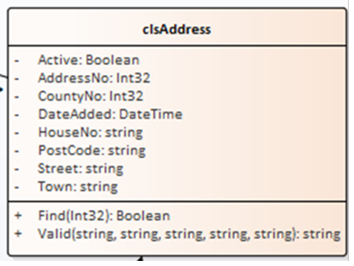
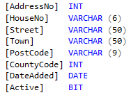

My attributes are modelled in the class design to the right.
We need to pick off the properties one at a time, create a test in the test class and from there generate the property.

Creating the first test
In tstAddress I will create a test for the first property “Active”.
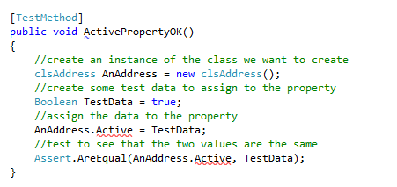
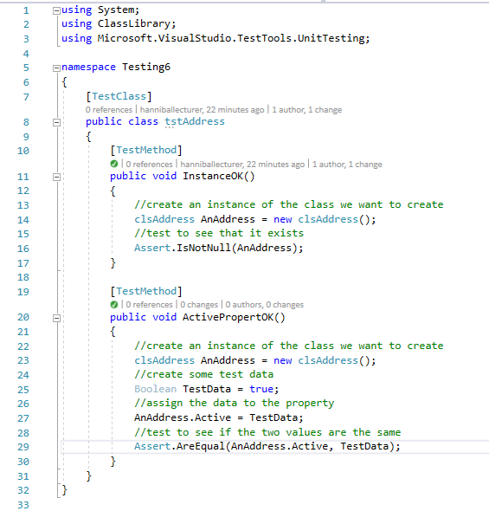
Your class code should look something like this…take note of the curly braces (most errors are down to these)

Run ‘All Tests’ from the main menu…
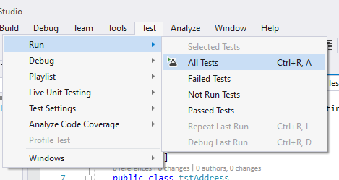

Watch them fail…
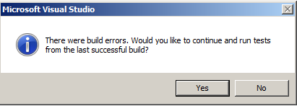
Important Reminder - As always click no here!
To fix the problem hold the mouse over the red underlining and select ‘Generate property ‘clsAddress.Active’.
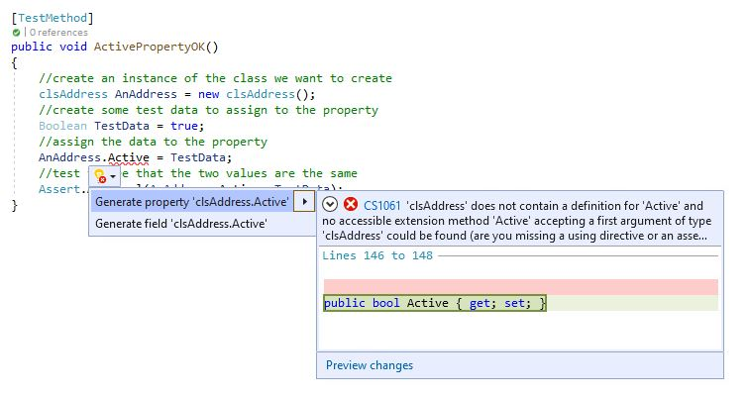
The red underlining should now disappear so let’s run the tests again. They should now pass.
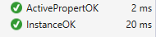
Open the code for clsAddress in the class library…
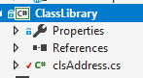
Double click the file class and you should see the code for the property created automatically here…
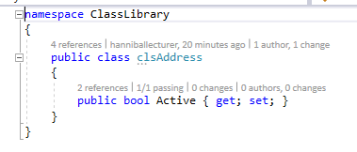
Notice also that having created the correct data type for the test data in your original test…
The correct data type has been used in the property…

Adding a Date Property
The next property we shall look at is DateAdded as it allows us to look at some useful code.
Look at the test code for this date property below…
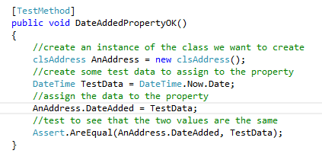
The thing about date tests is that we don’t want to be updating the date every time we run the test.
The following line of code gets around this problem.
DateTime TestData = DateTime.Now.Date;
What it does is assign the variable TestData with today’s date taken from DateTime.Now.Date
Create a test for your date property and make sure it works. You will need to follow the instructions in the previous section to generate the property and then ensure the test passes.

Adding the rest of the properties
To complete this work, you will need to create one test for each attribute in your table schema with an associated property generated from your testing procedure.
The code for the test class for all properties is below:
using System;
using Microsoft.VisualStudio.TestTools.UnitTesting;
using Class_Library;

namespace Testing6
{
[TestClass]
public class tstAddress
{

[TestMethod]
public void InstanceOK()
{
//create an instance of the class we want to create
clsAddress AnAddress = new clsAddress();
//test to see that it exists
Assert.IsNotNull(AnAddress);
}

[TestMethod]
public void ActivePropertyOK()
{
//create an instance of the class we want to create
clsAddress AnAddress = new clsAddress();
//create some test data to assign to the property
Boolean TestData = true;
//assign the data to the property
AnAddress.Active = TestData;
//test to see that the two values are the same
Assert.AreEqual(AnAddress.Active, TestData);
}
[TestMethod]
public void DateAddedPropertyOK()
{
//create an instance of the class we want to create
clsAddress AnAddress = new clsAddress();
//create some test data to assign to the property
DateTime TestData = DateTime.Now.Date;
//assign the data to the property
AnAddress.DateAdded = TestData;
//test to see that the two values are the same
Assert.AreEqual(AnAddress.DateAdded, TestData);
}

[TestMethod]
public void AddressNoPropertyOK()
{
//create an instance of the class we want to create
clsAddress AnAddress = new clsAddress();
//create some test data to assign to the property
Int32 TestData = 1;
//assign the data to the property
AnAddress.AddressNo = TestData;
//test to see that the two values are the same
Assert.AreEqual(AnAddress.AddressNo, TestData);
}

[TestMethod]
public void CountyNoPropertyOK()
{
//create an instance of the class we want to create
clsAddress AnAddress = new clsAddress();
//create some test data to assign to the property
Int32 TestData = 1;
//assign the data to the property
AnAddress.CountyNo = TestData;
//test to see that the two values are the same
Assert.AreEqual(AnAddress.CountyNo, TestData);
}

[TestMethod]
public void HouseNoPropertyOK()
{
//create an instance of the class we want to create
clsAddress AnAddress = new clsAddress();
//create some test data to assign to the property
string TestData = "21b";
//assign the data to the property
AnAddress.HouseNo = TestData;
//test to see that the two values are the same
Assert.AreEqual(AnAddress.HouseNo, TestData);
}

[TestMethod]
public void PostCodePropertyOK()
{
//create an instance of the class we want to create
clsAddress AnAddress = new clsAddress();
//create some test data to assign to the property
string TestData = "LE1 4AB";
//assign the data to the property
AnAddress.PostCode = TestData;
//test to see that the two values are the same
Assert.AreEqual(AnAddress.PostCode, TestData);
}

[TestMethod]
public void StreetPropertyOK()
{
//create an instance of the class we want to create
clsAddress AnAddress = new clsAddress();
//create some test data to assign to the property
string TestData = "Some Street";
//assign the data to the property
AnAddress.Street = TestData;
//test to see that the two values are the same
Assert.AreEqual(AnAddress.Street, TestData);
}

[TestMethod]
public void TownPropertyOK()
{
//create an instance of the class we want to create
clsAddress AnAddress = new clsAddress();
//create some test data to assign to the property
string TestData = "Leicester";
//assign the data to the property
AnAddress.Town = TestData;
//test to see that the two values are the same
Assert.AreEqual(AnAddress.Town, TestData);
}
}
}

Saving your work and merging your branch
Once you have done, save your work in Visual Studio and make sure you end your GitHub day by merging your perfect working code to the master repository and delete the unwanted branch.

